Problem Solution Analysis
This sub-phase analyzes how the problem can be solved using different approaches and justifies the selected solution.
2.1 Traditional Approaches
- Threshold-based temperature alarms
- Periodic manual inspection
- Physical temperature sensors
Limitations
- No predictive insight
- Late fault detection
- Sensor failures and maintenance costs

2.2 Analytical and Data-Based Approaches
- Statistical regression models
- Rule-based systems
Limitations
- Limited accuracy for non-linear data
- Poor adaptability to changing conditions

2.3 Machine Learning-Based Approach
The selected solution uses machine learning algorithms to model complex relationships between motor parameters and temperature.

Advantages
- Handles non-linear patterns
- Improves accuracy with more data
- Supports real-time prediction
- Scalable for multiple motors
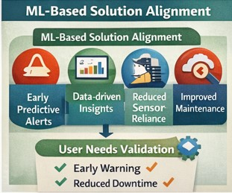

2.4 Justification of Chosen Approach
Machine learning was chosen because it:
- Offers higher prediction accuracy
- Adapts to changing motor behavior
- Enables real-time and future predictions
- Supports predictive maintenance strategies
This analysis confirms that a machine learning-based solution is the most effective way to solve the identified problem.

